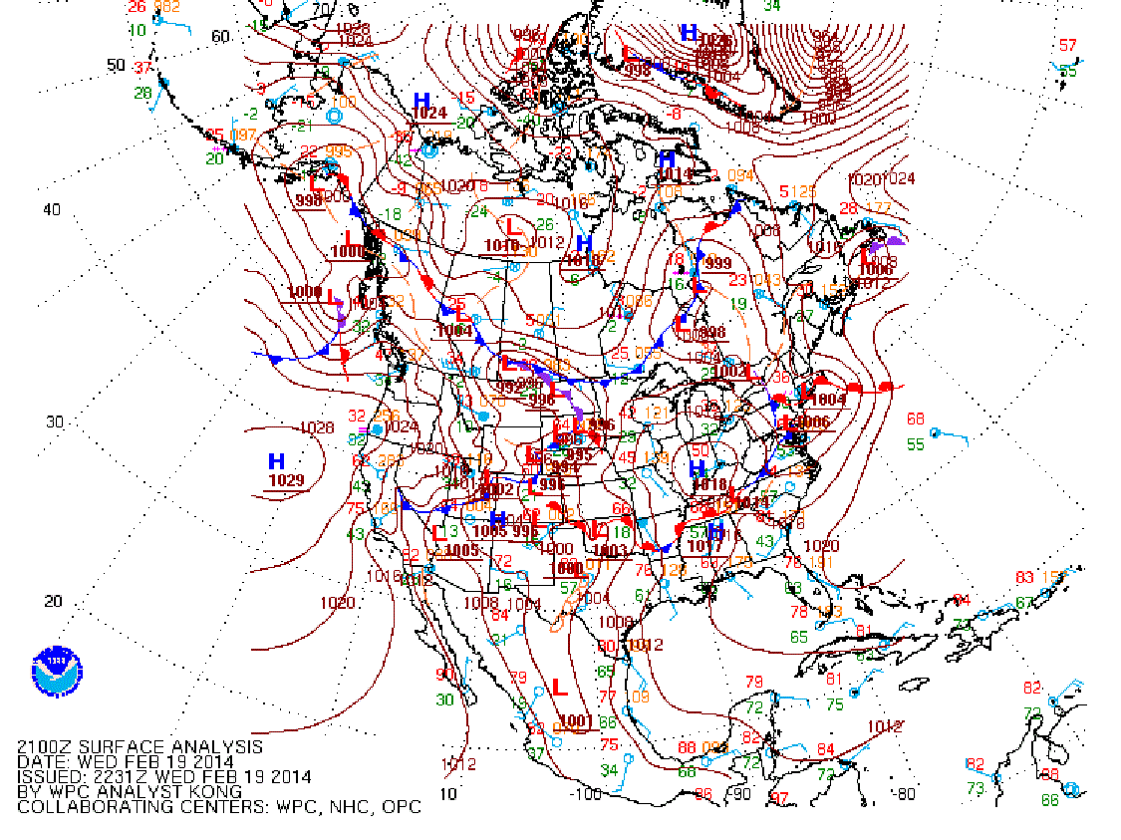
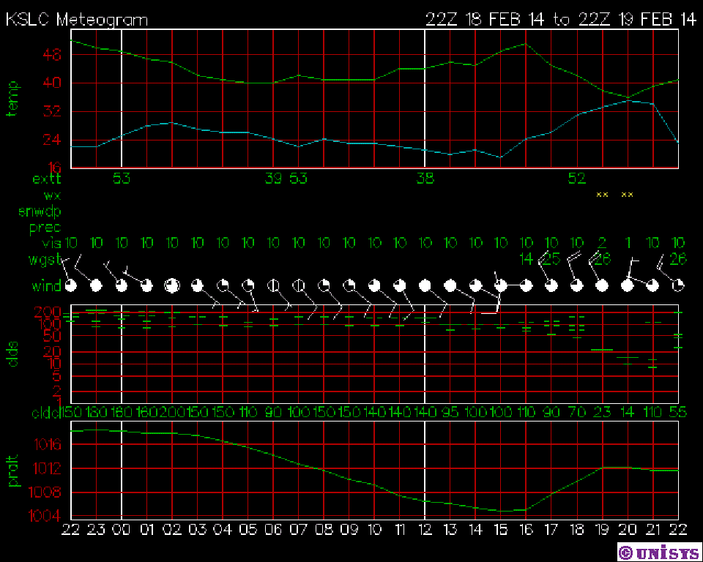

- Meteogram temperature dropped to around 35 degrees Fahrenheit at KSLC at around 1100 Mountain Standard Time(MST) on 19FEB2014
- Meteogram atmospheric pressure dropped to its lowest point in the day at around 0800(MST)
- Meteogram wind speeds increased to 26 knots at around 1200(MST) on 19FEB2014
- Meteogram visibility decreased from 10 miles to 1 mile at 1200(MST) then quickly increased back to 10 miles after the front passed.
- Meteogram there was a sudden change in wind direction at 0800(MST)
- Surface Analysis indicated cold winds from the north blowing across Utah on 19FEB2014

Having an interest in the mountains I tend to keep the National Oceanic and Atmospheric Administration (NOAA) website readily available on my desktop computer. I typically will check the weather(WX) from NOAA’s website once a day. It has never occurred to me that I can print a surface analysis from NOAA’s website.
Using the Meteogram from Unisys I can easily determine a sudden drop in atmospheric pressure which typically means worsening WX in the following hours.

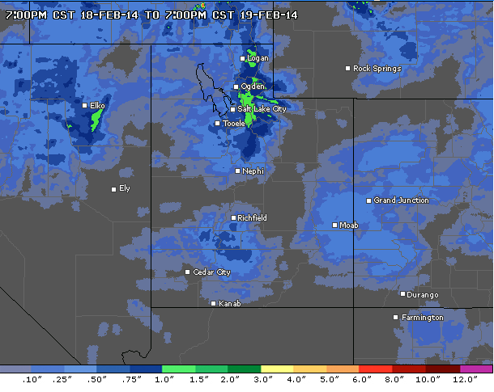 24 hour precipitation at the Salt Lake International Airport (acuweather.com)

