Kevin Chuba
English 2010
Mrs. Briggs
01May2014

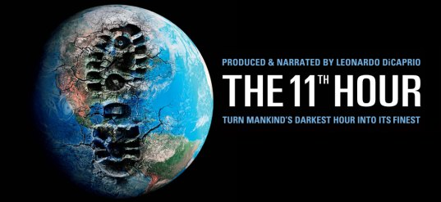
The 11th Hour is a documentary outlining the current and approaching environmental response to the escalating excess within the human race. The opening scene provides vivid examples of how powerful and destructive nature can be. Tornadoes rip houses to splinters, flood waters rage against shorelines, explosive fires torment cities; drought and famine wreak havoc on a small village. Mother Nature’s fury immediately attracts your attention in what assumes to be a warning! A warning to mankind that if change doesn’t occur now our climate may turn against us creating chaos in several parts of the world. The visuals seen thru out the documentary harness all aspects of life, creating a common interest for the global population.
Written by sisters: Leila Conners Petersen and Nadia Conner the 11th hour emphasizes the mistakes that mankind has made in the past, and currently making now. It promotes countless ideas to solve problems like using innovations such as the “Trident” system to produce sustainable energy using ocean waves. Don’t expect anything in this film to be sugar coated. The environmentalists interviewed are passionate about preserving nature and can be downright obtrusive. An opening statement suggests that ultimately we as a human race are committing suicide. The logic remains that if humans continue to destroy nature, we destroy ourselves in the process.
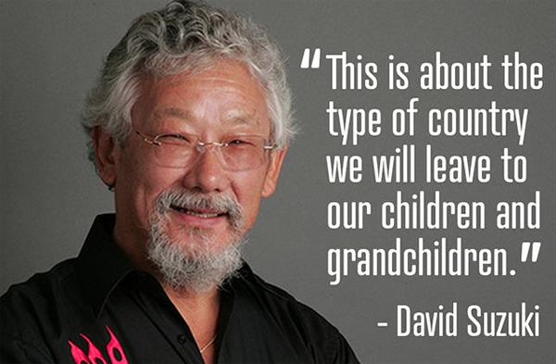
Leonardo Dicaprio is the producer and also acts as the narrator in the documentary. Although the film is not intended for great acting or an award winning performance it plants a seed, and is clearly a message to educate people that a sustainable future is necessary for our existence here on earth. The film offers interviews with environmentalist like David Suzuki, who is a retired science broadcaster and geneticist. He states that “we as human beings have so much potential and should revel in the things that keep us alive.”
The film puts huge amounts of pressure on the economy being the driving force behind the degradation of our planet. Whether it’s the cutting down of a tree, or drilling for oil the outcomes are the same a more degraded planet but more money in an individual’s pocket. The 11th hour suggests our economy is based on consumerism and is a throwaway society. It questions politics and who has ultimate authority to make a difference? Bringing home the idea that what you purchase helps to cast your vote saying “I approve” how this product was made.
Oftentimes, it is easier to be misguided than to live in a state of awareness, and accept one’s actions as being effectual. In order to fully be a part of this worldly existence, humankind must realize that its actions impact every element of the living Earth, either directly or residually. Simply because one is unable to immediately visualize the outcomes of his actions, does not mean that those effects are not taking place.

