Kevin Chuba
Sue Briggs
English 2010
01MAY2014

What to Believe?

Several years ago, I was having a conversation with my father about global warming. I remember saying “I think earth goes through a natural cycle of change.” Evidence from earth’s past led me to believe this to be true from cataclysmic events, such as the extinction of dinosaurs or Pangaea. Being a young and confident man I spoke my beliefs like they were real. Whether how outrageous my thoughts might have been I always stuck to my gut feelings in heavy discussion. I was surprised to hear my father agree with me, being the strong republican he was at the time. Believing most everything the government and media suggest being real. It was then when he listened to my position about climate change that I thought maybe I have a reasonable theory of my own. Now, at the age of 30 the same subject has manifested into a political and social network of dollar signs.
It affects all of us whether a believer or non believer, global warming is an increase in the earth’s atmospheric and oceanic temperatures widely predicted to occur due to the increase in the green house effect resulting especially from pollution. I think the key word to reflect on in the definition is pollution, though suggesting that anthropogenic green house gases (GHG) are causing the earth’s atmosphere to rise in temperature creating climate change. I don’t disagree with the notion that earth’s atmosphere is changing. I’m just not completely sold on the idea that humans are the #1 cause of global warming.
I think it’s important to be cognizant of when man started to emit GHG into the atmosphere; The Industrial Revolution began in the late 1700’s when man’s machine was invented. Primarily burning coal to operate machines and provide electricity for human activity. But to compare man’s timeline with earths would be vain, as humans are present to earth. I find it hard to believe that two hundred years of human activity has destroyed our planet. A living organism such as the earth is more resilient than some environmentalist give credit.
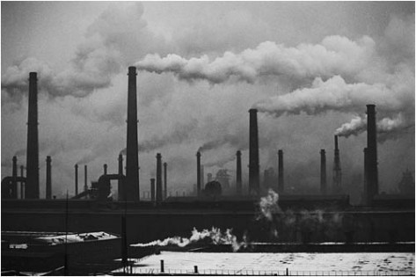
Carbon Dioxide (CO2) is a naturally occurring gas, and also a by-product of burning fossil fuels and biomass, as well as land-use changes and other industrial processes. It is the principal human caused greenhouse gas that affects the Earth's radiative balance. It is the reference gas against which other greenhouse gases are measured and therefore has a Global Warming Potential of 1. (Environmental Protection Agency. Glossary of climate change terms. Web. Sept. 9)

Is carbon good or bad? Earth is naturally made of carbon but how humans use carbon is a growing concern. Most skeptics will say that human GHG are very small compared to earth’s natural emissions. However natural CO2 emissions are balanced by natural absorption. Human CO2 emissions upset the natural balance and are causing the oceans and vegetation to absorb more CO2 than would otherwise without man’s contribution. Relatively new research is finding that the introduction of massive amounts of CO2 into our oceans is altering water chemistry and affecting the life cycles of many marine organisms, particularly those at the lower end of the food chain. (National Geographic Society. “Ocean Acidification Carbon Dioxide Is Putting Shelled Animals at Risk” National Geographic. 1996-2014. Web.) I am frightened by the thought that if our oceans no longer absorb CO2 from the atmosphere and support marine lives, this will likely cause a dead planet. Making James Lovelocks Gaia hypothesis relevant that one day earth will die. The Gaia hypothesis also suggest that earth repairs itself which is what I believe is currently taking place on our planet. Earth is using climate change as feedback to balance the global carbon cycle. Humans are a part of earth and therefore a part of Gaia which will likely adapt to its inhabitants.
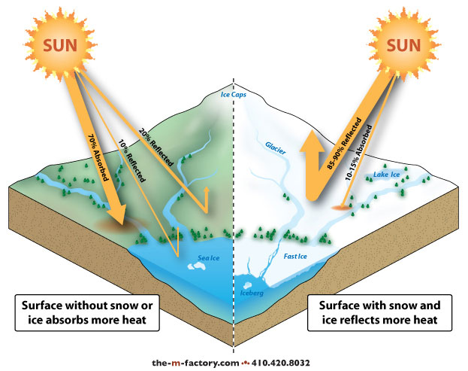
If it’s not GHG causing glaciers and ice sheets to melt then what is? A theory discovered by the international research initiative IceGeoHeat, led by the GFZ German Research Centre for Geosciences, is suggesting that the ice sheet in Greenland is melting partly because of heat from the earth's mantle. (Cobb, Douglas. “Ice in Greenland Due to Heat from Earth’s Mantle” Liberty Voice, Web. 13 Aug. 2013) The ice is actually melting from the bottom up. In any case a receding glacier or ice sheet does not reflect back the amount of solar radiation it once did, the Albedo affect. Albedo refers to the overall reflectivity of an object or surface, usually described as a percentage. (Hess Darrel, McKnight’s Physical Geography eleventh edition, (2014): Pg 84) The surface of earth is left naked, unable to protect itself from the sun. Every inch of ice and snow that melts results in more solar rays to be absorbed by the surface of earth. In affect; a faster and faster rate of temperature increase of our atmosphere. Man’s pollutants into the atmosphere combined with heat from earth’s mantle, along with a decrease in Albedo affect are major contributors to warming temperatures. It’s not hard to disagree with the fact that the sun is ultimately warming earth’s atmosphere and creating more severe weather and climate. In my opinion these are natural occurring factors of our planet.
For the sake of mankind let’s all hope that the warming temperatures are from green house gases and not a natural warming cycle. If humans are the cause of global warming then I’m optimistic that with the help of Mother Nature and natural selection our species will no doubt create a sustainable future. If temperatures are rising because of natural phenomena then it might be time to get out the tin foil and start reflecting back some solar rays. While scientist and research teams continue to study global warming I feel everyone has the right to be educated about rising temperatures and climate change. People who are misguided in natural disasters typically loose most everything. “It’s very clear that we are not prepared for the kind of events we’re seeing and how vulnerable we are to weather extremes”. (Borenstien, Seth. “Warming is big risk.” Climate report The Charleston Gazette 25 Mar. 2014: A.2. Print.)
I’m willing to bet the majority of the population on earth avoid the topic, global warming. People who don’t care about a sustainable future are typically the cause of an unhealthy planet. More people need to be educated about our home rather than taking it for granted. A sustainable future needs to start in early childhood development. Our schools should be required to teach an environmental responsibility module to every student. The interest towards a green future should be instilled in the hearts and minds of our young. The idea would be to reciprocate the responsibility with the rest of the planet.
The current and best approach for a greener planet is the “3R’s Rule: Reduce, Reuse, and Recycle”. Sheryl Eisenberg of the Natural Resources Defense Council writes the most effective of the 3r’s is to Reduce and is the best place to begin. (Eisenberg, Sheryl “The 3R’s still Rule” This Green Life, A Journal of Sorts (2008): Pg 2) The current trend of consumerism is wreaking havoc on our planet. Most every product that is purchased has some negative impact on earth whether it’s from packing material that ends up in a land fill, or emitting CO2 for production/transportation. We all need to consume less, buy local when possible, reuse what we already have and find more efficient ways to recycle waste products.
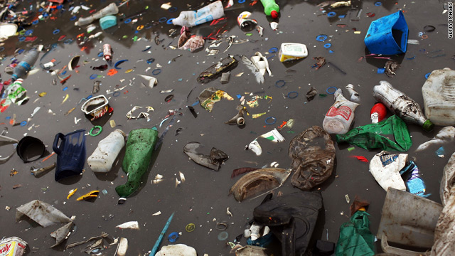
Consumption of goods and services worldwide increased by over a quarter from 1996 to 2006 CNN.com
One effective and money saving approach is “less is more”. Three words from Millburn’s and Nicodemus’s book Everything that Remains. (May, Patrick. “Minimalist to preach burgeoning in San Jose.” Oakland Tribune. Web.31 Mar. 2014) The minimalist approach is to embrace life with “less money, less stuff, and more meaning.” (Millburn and Nicodemus) This concept of less is more is so simple but is a huge hurdle for consumers to grasp. I am just as guilty as anyone but have been trying to live by this motto that “less is more” and why not, it saves me time and money!

