Kevin Chuba
Jon Allred
Met1010
03August2014

Free the Energy

The Sun is what makes life possible on Earth it’s the source of weather and climate without it humans would cease to exist. The sun is what moves ocean currents and creates the winds that wrap earth in a blanket of clouds. Taking it for granted, and disregarding its powerful energy is a mistake that we can’t afford any longer.
It’s no longer a secret that earth is warming which enables the climate to change. Rapid heating and cooling of earth’s surface is creating more powerful storms and severe weather than we have documented in previous years. What can our race do? Can we attempt to change the course of our own actions?
There is a majority of people on the planet that get it and are willing to absorb free energy. I’m extremely interested in harnessing free energy but, still cognizant to do so. We don’t live in the Stone Age so why are we using fuel from the past. The most powerful thing in our universe is not actively being utilized for energy, why?
I performed a simple experiment in hopes that the outcome would provide evidence that solar insulation and the Albedo affect can greatly reduce the temperature of earth’s atmosphere. The theory is simple, when a car is parked on a hot summer day it heat’s up inside the vehicle hotter than the outside temperature. When the car door is opened all the heat escapes into our atmosphere making it hotter outside than if the vehicle didn’t exist. I attempted to reduce the heat inside my vehicle by using reflective material to cover the windshield preventing the sun’s UV rays from entering the parked car.

These are the results from my experiment on 27July2014:
- The sun was directly overhead and truck was facing west
- Outside air temperature remained the same at 40 degrees Celsius (104’F)
- At 1520 hours the recorded temperature Inside truck WITH the reflective windshield was 52 degrees Celsius (125’F)
- At 1620 hours the recorded temperature inside the truck WITHOUT the reflective windshield was 53 degrees Celsius (127’F)

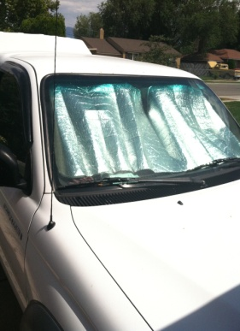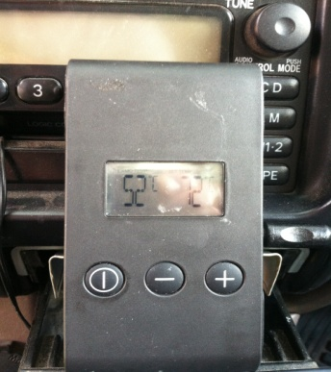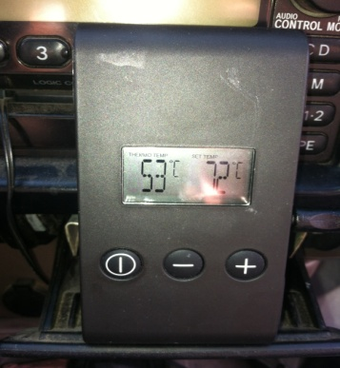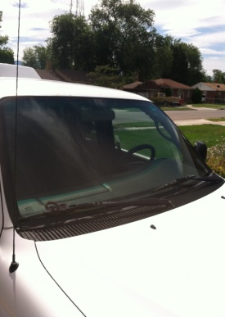

- RESULTS DISAPOINTING
In conclusion I found there to be one major issue in my research that may have caused such poor results. The problem with my experiment is that the solar shield was on the inside of the windshield still allowing UV light to still penetrate into the cab of the vehicle. If the solar shield were on the outside of the windshield I think temperatures would have stayed much cooler inside the vehicle. This minor fault in my research may influence me to continue with the solar shield project and Free the Energy being trapped in our atmosphere. Although my research was bleak and possibly out of context I enjoyed putting this together furthering my knowledge on the sun’s effect on planet earth.

