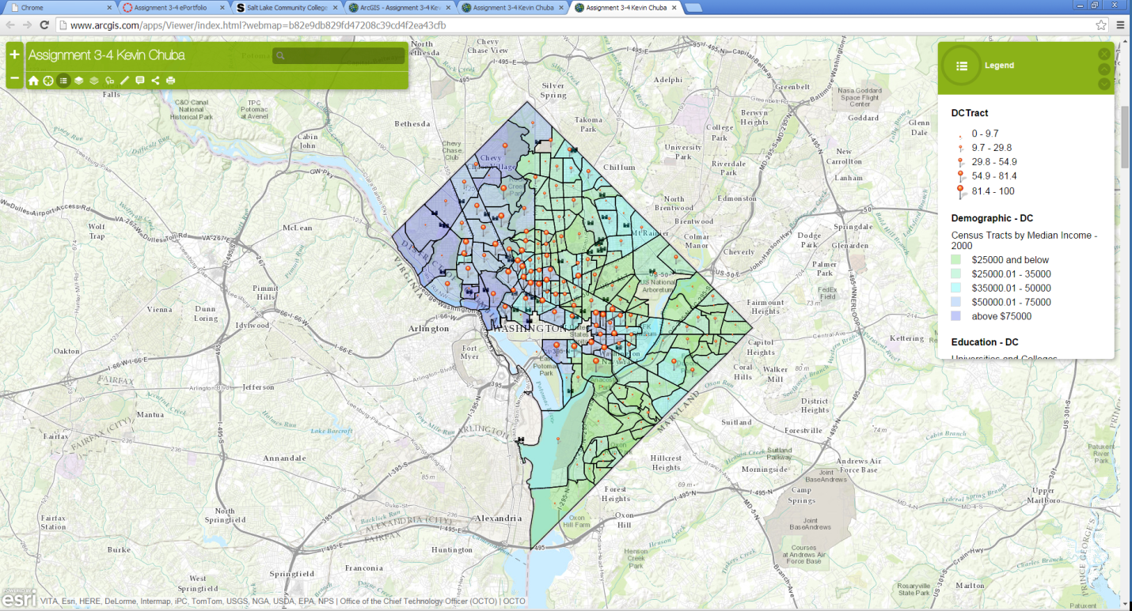

In this assignment I choose to show the relevance between people who have bachelor’s degrees compared to median income. I also included college campuses with their location compared to people who have bachelor’s degrees.
Online mapping could be used with many of my hobbies to include rock climbing and hiking. It would be interesting to map out all of the climbing and hiking routes I have done. I have climbed to the summits of several mountains which I feel could be easily mapped out with this online software. I could also map locations where I want to go and climbs that I have yet to do.
Using data from ARCGIS could help locate a destination where I would choose to live one day, determine your salary, average price of a home, cost of living, education, growth rate, ect. Taking data and layering it on a map could essentially outline your entire life planning out who you will become in this world and eventually fore casting the future.

