Kevin Chuba
Sue Briggs
English 2010
18FEB2014
Our Home
The terrestrial planet we inhabit is considered to be one living organism named “Gaia”. Gaia is the living earth theory providing for itself and managing to create pretty optimal conditions for a very looooooooooooong time. Gaia has created such an environment to sustain life. The most advanced form of life is growing and consuming faster than she may allow.
Gaia is Greek for “Life”. The life provided by the earth functions as a whole to maintain. Everything within Gaia is used to sustain life for all inhabitants. Algae, that grows in oceans gives oxygen back into the world that a BIG OL’ Grizzly bear uses to breathe. That same bear discards a deer carcass that was eaten for lunch. The carcass creates a fly. The fly is eaten by a frog. Every pattern of life contributes to keep Gaia in equilibrium.
Unfortunately for Gaia, one of her most intelligent and sophisticated inhabitants is causing her more harm than good. Humans continue to consume resources at an alarming rate just too survive. While global populations increase, global deforestation is occurring at the rate of one football field per second! (http://slccgeosciencedepartment.yolasite.com) Increasing the consumption of natural resources is causing her to change. Without being able to actually interview Gaia, I used the “Gaia Hypothesis” to help better understand our home.
- GAIA was born when a HUGE, cold, diffuse gas cloud or Nebula began to contract inward, owing to its own gravitational collapse. (McKnight’s Physical Geography pg. 10) Gaia will one day die.
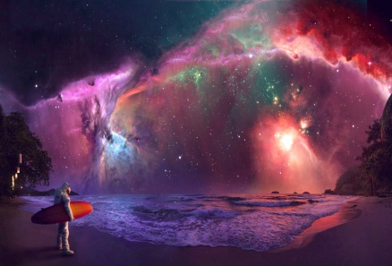 What Nebula may have looked like
- GAIA will have growth and development. She is and has been evolving. She shows us through studying her surface, or from the growth of trees. She has been through several changes and has had several different inhabitants.
- GAIA will repair herself. Consider an old tree that fell in the woods. This creates a new opening for something else to receive sunlight and grow. "You may find it hard to swallow the notion that anything as large and apparently inanimate as the Earth is alive” (James Lovelock, The Ages of Gaia)
- GAIA has a memory, and we can study her past. For example: a fossil of an alligator that is found miles from water gives reason to believe that water once covered the particular area.
- GAIA replicates herself by building a foundation to which she makes copies of previous life forms. She uses her knowledge in order to sustain life.
As a whole our species really does nothing for Gaia. We are inhabitants here merely consuming everything that she has worked for. Millions of years have passed in order to create and support a living biome. The earth’s most intelligent offspring is causing her to struggle. She cannot keep up with the rapid growth of her own design. With nearly 7 billion people on earth, we currently add about 131 million people each year, at a rate of 15,000 births per hour. (Diversity Amid globalization pg. 17) Physical signs show us the current state Gaia is in. There is strong evidence that glaciers are receding. There is depletion of fish in her oceans. There is massive clearing of rain forests and loss of more than just the trees! Entire ecological cycles are lost.
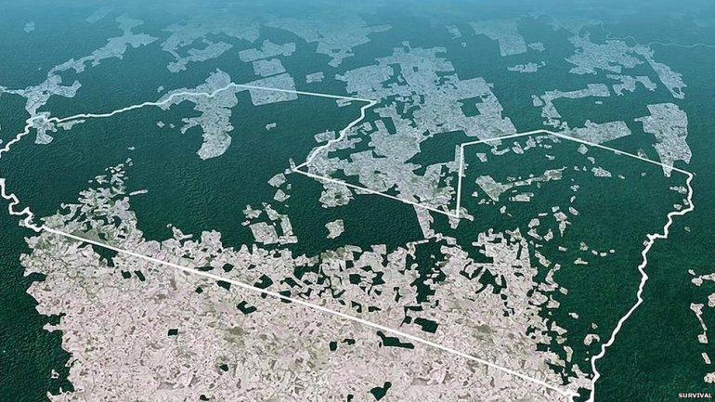 Deforestation of the Amazon rain forest
Throughout history, evidence shows us that she will find a way to take care of herself. Is she a destructive, relentless mother? Does she fight back with catastrophic powers? Tsunamis, earthquakes, and hurricanes may be a way of cleansing her. If Earth is alive, does Gaia then act like a living thing to defend itself? Is she simply taking care of herself so that Gaia can continue on her journey of life?

