Kevin Chuba
Dr. Shaefer
Anthropology_1020
06FEB2015

Comparing Humans to Finches

Introduction: Evolution has been discussed long before I was born and made aware of the scientific method. It’s taken me 31 years of life to have actually done an experiment of my own. The activity (experiment) done in class relates to Charles Darwin’s research on finches’ and natural selection. Darwin’s evolutionary theory suggests that “competition between two similar species can drive animals to evolve in different directions.”
Researching evolution takes years which Peter and Rosemary Grant have been doing in the Galapagos Islands since 1982 further researching ground finches has shown the phenomenon known as “character displacement.” The beaks of finches have changed in order to adapt to the environment and also changed to compete with other local finches in the area.

Materials and Methods: The activity done in class simulated how competition for food can change the physical appearance of and animal over time. Using objects which are considerably similar to a bird’s beak like tweezers or a hairclip to pick up seeds to eat. All together there was seven different kinds of beaks (utensils) used in the class activity. Tongs, chopsticks, clothes pins, large hair clips, tweezers, binder clips and, small hair clips. The food was actual seeds which each student had one minute to pick up with their beak and put into a small cup (stomach). I proposed that my beak (Clothes pin) would increase in frequency and have a greater success rate than the other utensils used in the experiment. I chose this to be true because of the competitive nature that is instilled within thyself and the method I chose to use my beak.

Results:

Beak Types | Beginning Frequency | Frequency Round 1 | Frequency Round 2 | Frequency Round 3 | Frequency Round 4 | Frequency Round 5
Tongs | 6.25 | 6.25 | 6.25 | 6.25 | 6.25 | 3.125
Chopsticks | 15.625 | 21.875 | 18.75 | 15.625 | 15.625 | 12.5
Clothes Pin | 15.625 | 9.375 | 12.5 | 12.5 | 15.625 | 18.75
Lg Hair Clips | 15.625 | 15.625 | 12.5 | 12.5 | 12.5 | 12.5
Tweezers | 15.625 | 18.75 | 21.875 | 25 | 28.125 | 31.25
Binder Clips | 15.625 | 12.5 | 9.375 | 9.375 | 6.25 | 6.25
Sm Hair Clips | 15.625 | 15.625 | 15.625 | 15.625 | 12.5 | 12.5

Graph showing the success rate of beak types
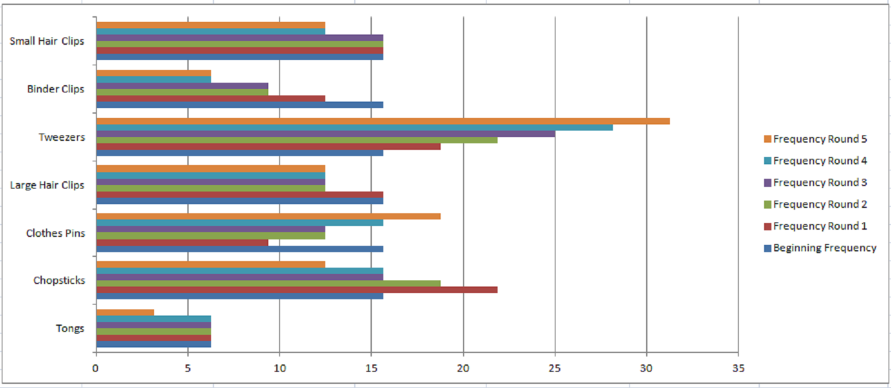
The results of the in class activity are shown here in both the graph and data table. The Graph shows how the tweezers were the dominant beak type and had a higher frequency rating compared to the other beak types. The tweezers were able to collect more food and thus had more offspring which allowed this type of beak to carry on its dominant gene.
Conclusion: My hypothesis that the clothes pins would thrive is supported marginally with the data provided in both the frequency table and graph. The clothes pins started to increase in frequency towards the end of the experiment. The way in which I used my clothes pin to collect seeds may have altered the results because I used the clothes pin in a manner like it they were tweezers.
This experiment has validity much like actual research because there was competition, adaption to how utensils were used, and drought which caused a mutation in one of the animals. These situations are likely happening in a real world environment.
Discussion: The scientific method is the corner stone of all science and is how we can draw conclusion to support theories. The steps in any scientific method can be similar to the following steps.
1. Identify a problem
2. Research problem
3. Observe problem
4. Develop a hypothesis
5. Gather data
6. Ask questions
7. Test hypothesis with measurements
8. Draw conclusion
9. Falsify/Refine
The scientific method is used primarily in all sciences especially the four sub fields of Anthropology which include:
Social Anthropology- The study of how people interact with each other through religion and cultural beliefs.
Archaeology- Studying artifacts from the past like tools to understand how people lived years ago.
Linguistic Anthropology- Studying languages and how people use them to communicate with each other.
Biological Anthropology- Studying traits that are inherited to offspring.

This activity used the scientific method though observing which beak types had a higher success rate at collecting food. Gathering the data and documenting which beak had a higher frequency rate. Drawing a conclusion to which beak was better at collecting food and proving or disproving the original hypothesis.

Evolution by natural selection can be described as favorable variations which will increase in frequency in the population.
1. Variability
2. Inheritance
3. Competition
4. Differential reproductive success

This activity provided evidence that natural selection was happening due to the increase in frequency that tweezers would appear. A greater frequency in tweezers made the competition for food more difficult for the less adapted beak types. Over time the inherited beak type had a much higher rate of success within the population.

References:

“Evolution” of Finch Beaks-Again, Dr. Georgia Purdom, July 19, 2006, https://answersingenesis.org

“Instant” Evolution Seen In Darwin’s Finches, Study Says, Mason Inman, July 14, 2006
http://news.nationalgeographic.com

