Assignment 1-1
Kevin Chuba

Top ten most populous states and territories, 2010

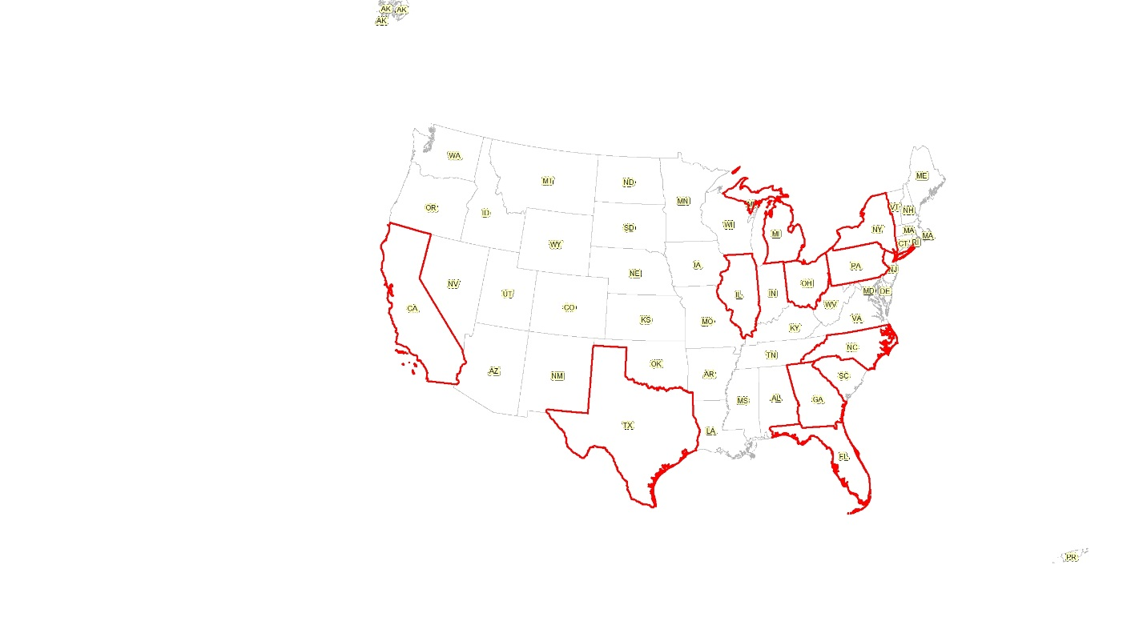
Statistics on Population by race

 | Population by race: 10 most populous states and terrortories | Population by race: All states and territories | Percentage of population by race: 10 most populous states and territories
White | 115248734 | 226378365 | 0.509097828
Black | 22403541 | 39390817 | 0.568750351
American Indian/ Eskimo | 1024503 | 2952087 | 0.347043634
Asian | 9590551 | 14681083 | 0.653259095
Hawaaiian- Pacific Islander | 214870 | 540383 | 0.397625388
Other | 13310621 | 19397273 | 0.686210943
Total: | 161792820 | 303340008 | 0.533371187
The following Is a document showing the top ten most populous states. There is a pattern with climate and areas with a great deal of employment.

